# **Template – Online Application with DocuSign**

The template named “Template – Campus University Online Application” is applicable to CampusNexus Student.

## Purpose and Outcome

This sequence is intended to be used by students who enroll into a program at your institution. This is an authenticated sequence that requires the user to have a Portal user name and password.

The application process involves collection of demographic information for the student, obtaining previous education information, collection of documents and necessary signatures using DocuSign, and managing other tasks and activities to enroll the student in a program. The information is used to create the applicant record for the student.

## Prerequisites

The template was built with Forms Builder using the applications listed below. The template is forward compatible with later versions of the listed applications.

|  |  |
| --- | --- |
| **Application** | **Minimum Version** |
| Forms Builder Designer and Renderer | 3.3 |
| Web Client for CampusNexus Student | 18.2 |
| Workflow Composer | 2.5 |
| Packages installed from Package Manager in Workflow Composer | Activities and Contracts (V1) 18.2.0  Activities and Contracts (V2) 18.2.0  Forms Builder Contracts 3.3 |
| Workflow Tracking Database | N/A |
| Staff STS 2.1 | 2.1 |

### Step 1: Download and Import the Template

1. Download the template file to your environment (local drive or network location).
2. Log into **Forms Builder** and select the **Form Designer tile**.
3. Click the **Export/Import** tile.
4. Select the **Import** tab.
5. Click **Select exported file** and navigate to the downloaded template file.
6. Click **Import**.

* [Export/Import](https://help.campusmanagement.com/FB/3.x/Content/ExportImport.htm)

### Step 2: In Form Designer…

1. From the Forms slide out, select **Campus University Online Application – Campus Selection**.
2. Optional - Customize the form for your environment. Modify field/component properties or add/remove fields/components.
3. Repeat steps 1 and 2 for the following forms:

**Campus University Online Application – Step 1**

**Campus University Online Application – Step 2**

**Campus University Online Application – Step 3**

**Campus University Online Application – Step 4**

**Campus University Online Application – Step 5**

**Campus University Online Application – Step 6**

* [Fields](https://help.campusmanagement.com/FB/3.x/Content/Fields.htm) and [Components](https://help.campusmanagement.com/FB/3.x/Content/Components.htm)

### Step 3: In Sequence Designer…

1. Select the **Template - Campus University Online Application** sequence.
2. Click **Save As** to create a copy of the sequence/workflow and customize the copy for your use. This way you can always refer to the original sequence/workflow you downloaded.
3. Optional - Customize the sequence properties for your environment.
4. Optional - Add a custom style (theme) associated with your campus.

* [Themes](https://help.campusmanagement.com/FB/3.x/Content/Themes.htm)

1. Open the sequence workflow. Depending on your environment, either click **Open Workflow** in Sequence Designer or launch a local installation of Workflow Composer.

* [Opening Workflows for Sequences](https://help.campusmanagement.com/FB/3.x/Content/HostedEnv.htm)

### Step 4: In Workflow Composer…

1. Select the **Arguments** tab and note that the following arguments have been created due to entity fields on form.

* studentEntity
* studentEthnicityEntity
* degreeEntity
* applicantEntity
* studentPreviousEducationEntity
* studentRelationshipAddressEntity
  + [Updating a Form After Creation of a Sequence](https://help.campusmanagement.com/FB/3.x/Content/AddingEntities.htm) and [Components](https://help.campusmanagement.com/FB/3.x/Content/Components.htm)

1. Double-click the first sequence in the workflow flow to view the overall layout of the workflow.

Note: This is a state machine workflow. Each form is a state, and the arrows are transitions from one state to another.

* [State Machine Workflows](https://help.campusmanagement.com/FB/3.x/Content/StateMachineWorkflows.htm)

1. Double-click the **Campus University Online Application – Campus Selection** state and click the **Next** transition.

Note that the workflow executes the following activities when a student selects Next on the form in your form sequence:

* + LookupUser
  + GetEntity<StudentEntity>
  + Assign
  + LookupReferenceItem
  + LookupStudentDocuments

You do not need to modify any properties for these activities.

1. Double-click the **Campus University Online Application – Step 1** state and click the **Next** transition.

Note that the workflow executes a LogLine activity to log all the values saved on the studentEntity when the student fills out the form.

1. Double-click the **Campus University Online Application – Step 2** state and click the **Next** transition.

This section creates the applicantEntity and assigns default values for certain fields.

Modify the hard-coded assignment values for your CampusNexus Student environment. To get the values, you may either query the database directly or use the LookupReferenceItem activity within the workflow.

Simply drag/drop the **LookupReferenceItem** activity into the workflow. Select the **Type** you are looking for (e.g., School Status) and then select the Item you are looking for within that Type (e.g., Pending Applicant). The activity will return the hard-coded Id value (e.g., 58).

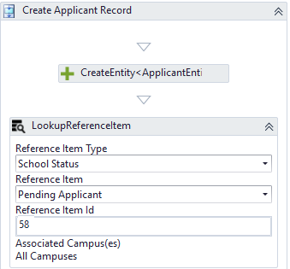

* [LookupReferenceItem activity](https://help.campusmanagement.com/WF/Content/Workflow/LookupReferenceItem.htm)

The following Assign statements must be updated as appropriate for your environment using database queries or LookupReferenceItem activities.

* applicantEntity.SchoolStatusId
* applicantEntity.ApplicantTypeId
* applicantEntity.EnrollmentStatusId

The applicantEntity values retrieved on the Campus University Online Application – Step 2 form are saved to the log using a LogLine activity.

1. Double-click the **Campus University Online Application – Step 3** state and click the **Next** transition.

This section creates the studentPreviousEducationEntity. You do not need to modify any properties on the CreateEntity activity.

1. Double-click the **Campus University Online Application – Step 4** state and click the **Next** transition.

This section assigns default values to the studentPreviousEducationEntity and logs the saved values. You do not need to modify any activities in this section.

1. Double-click the **Campus University Online Application – Step 5** state and click the **Next** transition.

This section displays disclosure information to the student. There are no additional workflow activities.

1. Double-click the **Campus University Online Application – Step 6** state and click the **Next** transition.

This section saves the entity values we assigned and/or were completed on the form by the student. We are also updating some values in the applicant record that we discovered are not getting updated by the service. We do this by using the ExecuteDataReader and ExecuteQuery activities. We are also validating the form data upon Save.

You do not need to modify any activities in this section.

1. Click the **Default-Frame** link at the end of the Next transition of Campus University Online Application – Step 6.

This section assigns the information needed to create the PDF file of the application form and populates the DocuSign activities and assignments.

You do not need to modify any activities in this section.

If you modified any form names, you will have to update the URL value accordingly.

1. Click the **Submit** link at the end of the Default-Frame section. The student will select Submit when the DocuSign process is complete. The workflow takes the signed PDF and updates the document center in the CampusNexus Student database accordingly.

This workflow section checks if the document is assigned to the student record.

* If it is, the workflow updates it by inserting and attaching the signed PDF and updating the document status.
* Otherwise, the workflow creates the document, attaches the signed PDF, and updates the document status.

You need to modify the CreateDocument activity in this section to select the appropriate Document Status from the values configured in your database.

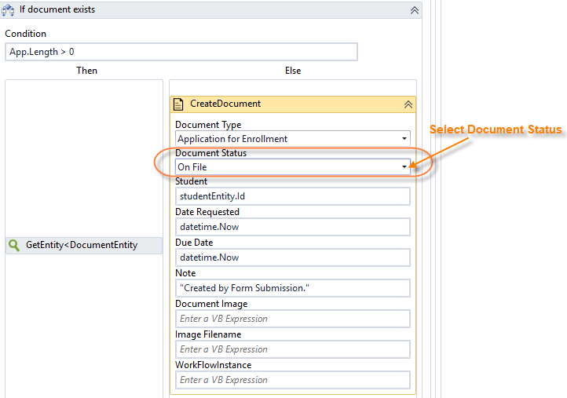.

1. Click the **Publish** button in the ribbon of Workflow Composer. Select the check box **Enable This Workflow Version?** and click **Publish.**
   * [Saving and Publishing Workflows](https://help.campusmanagement.com/WF/Content/Workflow/PublishWorkflow.htm)

### Step 5: In Forms Renderer…

Select your sequence and try it out! Upon completion of the application form, the student record in the database should be updated to a “Pending Applicant” status and the application document should be stored under in Contact Manager with today’s date.

* [Sequence List](https://help.campusmanagement.com/FB/3.x/Content/SequenceList.htm)

### Step 6: Lastly…

Once your updated sequence has been tested successfully, it is recommended that you disable the workflow for the original Template version.

1. In Workflow Composer, in the Server section of the ribbon, click **Open**.
2. Find the workflow named **Template – Campus University Online Application**.
3. Clear the **Enabled** check box and click **Save**.